DeepSkilling Week 1 Assessment

DESIGN PATTERNS AND PRINCIPLES

Exercise 1 : Implementing the Singleton Pattern

Code:

**Logger.java:**

package java_handson;

public class Logger {

private static Logger *instance*;

private Logger() {

System.*out.*println("Logger instance created");

}

public static Logger getInstance() {

if (*instance* == null) {

*instance* = new Logger();

}

return *instance*;

}

public void log(String message) {

System.*out*.println("Log: " + message);

}

}

**SingletonTest.java:**

package java_handson;

public class SingletonTest {

public static void main(String[] args) {

Logger logger1 = Logger.*getInstance*();

Logger logger2 = Logger.*getInstance*();

logger1.log("First message");

logger2.log("Second message");

if (logger1 == logger2) {

System.*out*.println("Both logger1 and logger2 are the same instance.");

} else {

System.*out*.println("Different instances detected. Singleton not working correctly.");

}

}

}

OUTPUT:

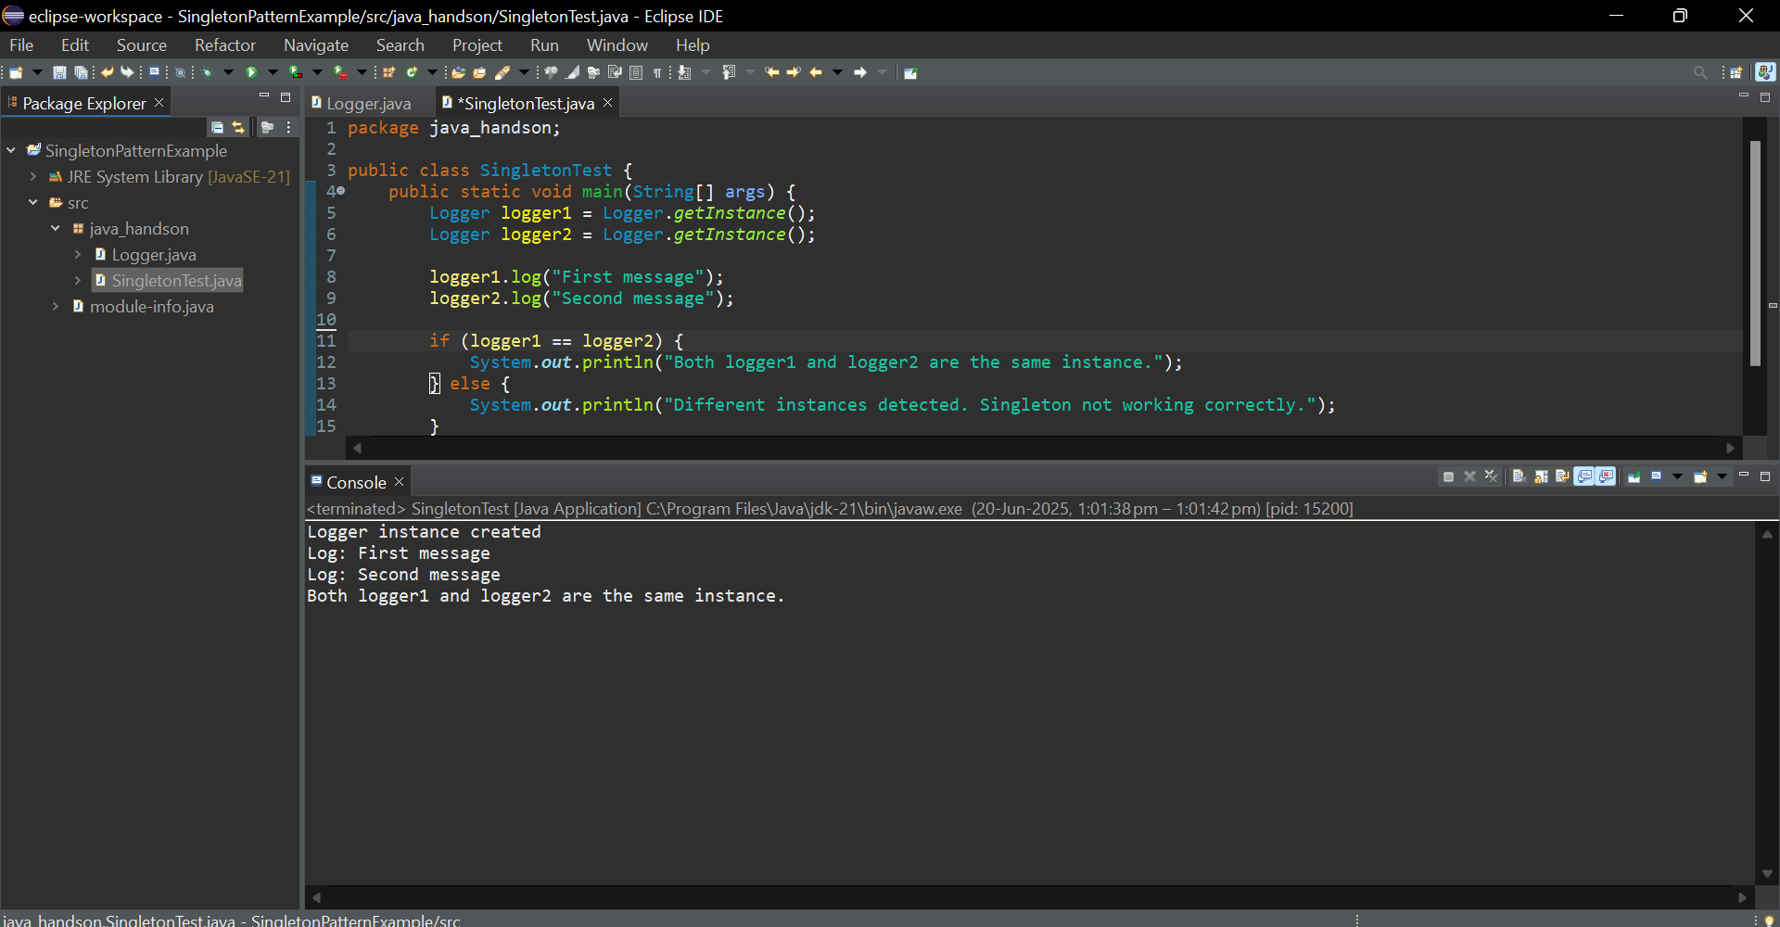

Exercise 2 : Implementing Factory Method Pattern

**Document.java :**

package pack;

public interface Document {

void open();

}

**WordDocument.java :**

package pack;

public class WordDocument implements Document {

public void open() {

System.*out*.println("Opening a Word document.");

}

}

**PdfDocument.java :**

package pack;

public class PdfDocument implements Document {

public void open() {

System.*out*.println("Opening a PDF document.");

}

}

**ExcelDocument.java** :

package pack;

public class ExcelDocument implements Document {

public void open() {

System.*out*.println("Opening an Excel document.");

}

}

**DocumentFactory.java :**

package pack;

public abstract class DocumentFactory {

public abstract Document createDocument();

}

**PdfDocumentFactory.java :**

package pack;

public class PdfDocumentFactory extends DocumentFactory { public Document createDocument() {

return new PdfDocument();

}

}

**ExcelDocumentFactory.java :**

package pack;

public class ExcelDocumentFactory extends DocumentFactory {

public Document createDocument() {

return new ExcelDocument();

}

}

**FactoryPatternTest.java :**

package pack;

public class FactoryPatternTest {

public static void main(String[] args) {

DocumentFactory WordFactory = new WordDocumentFactory();

Document wordDoc = WordFactory.createDocument();

wordDoc.open();

DocumentFactory PdfFactory = new PdfDocumentFactory();

Document pdfDoc = PdfFactory.createDocument();

pdfDoc.open();

DocumentFactory ExcelFactory = new ExcelDocumentFactory();

Document excelDoc = ExcelFactory.createDocument();

excelDoc.open();

}

}

OUTPUT:

